27-05-2025

Mekapothula Durga Venkateswara Reddy – 22BCB7296

1.available databases

2.Adding and dropping the databases.

Adding collections (“student”) to the database.

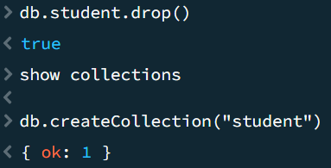3.Deleting the collection

4.Inserting data into the collections